**Dashboard 1: UNESCO World Heritage Site Overview**

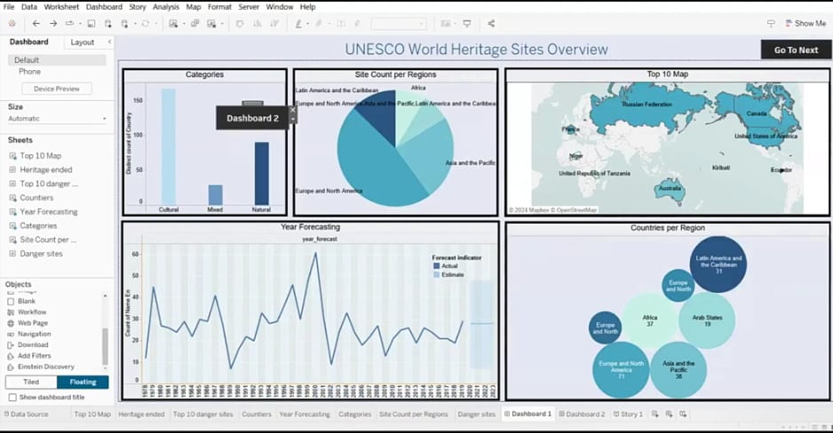

**Dashboard 2:**

